**Minecraft MOD APK: How to Get More Resources and Unlock Hidden Features**

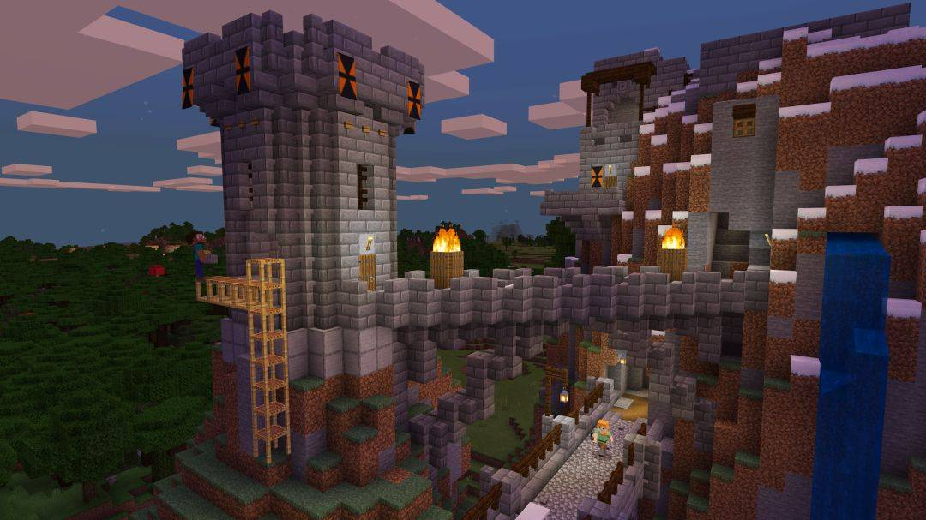

Minecraft, a globally popular sandbox game developed by Mojang Studios, has captivated millions of players worldwide with its creative gameplay and [Minecraft MOD APK](https://minecrftapkmod.com/minecraft-mod-apk/) limitless possibilities. The game allows players to mine, craft, build, and explore an expansive virtual world. With the rise of mobile gaming, Minecraft MOD APK has become an increasingly popular choice for players looking to enhance their gaming experience on smartphones and tablets.

A Minecraft MOD APK is a modified version of the game that comes with additional features and tweaks that are not available in the official game. Whether you're looking for unlimited resources, hidden features, or new gameplay mechanics, a Minecraft MOD APK can offer you a variety of advantages. This article will guide you through how to get more resources and unlock hidden features with Minecraft MOD APK, while also covering key aspects of gameplay and the benefits of using mods in the game.

What is Minecraft MOD APK?

Minecraft MOD APK is a modified version of the original Minecraft Pocket Edition, designed for Android devices. This modified version of the game offers players various enhancements, such as unlimited resources, unlocked skins, and access to special features that are typically restricted in the official game.

Mods (short for modifications) are typically created by third-party developers who modify the game's code or assets to add extra content, improve performance, or alter gameplay mechanics. These modifications can range from simple tweaks, such as removing ads, to more complex additions, like new items, creatures, or building structures.

Why Use Minecraft MOD APK?

Minecraft MOD APKs provide a significant advantage over the regular version of the game. By using mods, players can unlock hidden features, gain more resources, and access special abilities that make the game even more enjoyable and immersive. The main benefits of using a Minecraft MOD APK include:

Unlimited Resources: In the regular game, players must mine and craft their resources from scratch, which can be time-consuming. However, with a MOD APK, players can access unlimited resources such as diamonds, gold, and iron, enabling them to build massive structures and explore the world without constraints.

Unlock Hidden Features: Minecraft's official game offers a wide array of features, but some are hidden or locked behind achievements or in-app purchases. With a MOD APK, players can unlock these hidden features, such as rare skins, advanced tools, and custom game modes.

Customization and Personalization: Mods also enable players to personalize their Minecraft experience by adding new textures, skins, and models that are not available in the standard game. This allows players to create a more unique and personalized world.

Enhanced Gameplay: Minecraft MOD APKs often come with improved gameplay mechanics, including faster crafting, increased inventory slots, and the ability to fly. These enhancements streamline the gaming experience, allowing players to focus on building and exploring without limitations.

How to Get More Resources in Minecraft MOD APK

If you're looking to get more resources in Minecraft, the MOD APK version of the game is the perfect solution. Here's a step-by-step guide on how to unlock an abundance of resources and maximize your gameplay:

1. Install Minecraft MOD APK

Before you can start collecting more resources, you first need to download and install the Minecraft MOD APK. Here's how:

Search for a Trusted Source: Ensure that you download the Minecraft MOD APK from a reputable website to avoid potential security risks. Look for websites that offer verified MOD APK files with positive user reviews.

Enable Unknown Sources: To install the MOD APK on your Android device, you will need to enable installation from "Unknown Sources" in your device's settings. Go to Settings > Security > Unknown Sources, and toggle it on.

Download and Install the APK: Once the source is verified, download the APK file and tap on it to install. The installation process should take just a few minutes.

2. Access Unlimited Resources

Once you've installed the Minecraft MOD APK, you can access unlimited resources in your game. These resources include:

Diamonds: With the MOD APK, you no longer need to spend hours mining for diamonds. Simply open your inventory, and you'll find an abundance of diamonds at your disposal.

Gold, Iron, and Other Materials: Apart from diamonds, you can also unlock an infinite supply of other materials like gold, iron, coal, and emeralds. These resources will allow you to craft powerful tools, armor, and weapons.

Blocks and Items: The MOD APK grants you access to rare building blocks and items that are usually hard to find or require extensive gameplay to unlock. These can be used for creative building or to enhance your adventures.

3. Use Cheats and Console Commands

Many Minecraft MOD APKs come with built-in cheats and console commands that allow you to manipulate the game's mechanics. These cheats enable you to instantly spawn resources, build structures, or defeat enemies without much effort. Some common cheats include:

Give Command: Use the /give command to receive a specific amount of any resource or item.

Time and Weather Control: You can use commands like /time set day or /weather clear to control the in-game time and weather.

Teleportation: Teleport quickly to any location in the game world using the /tp command.

These cheats allow you to access a range of resources and features without the limitations of the standard game.

Unlocking Hidden Features with Minecraft MOD APK

In addition to acquiring more resources, Minecraft MOD APKs unlock hidden features that are not available in the official game. Here are some of the most exciting features you can unlock:

1. Custom Skins and Textures

With the MOD APK, you can customize your character's appearance with unique skins that are not available in the standard game. These skins range from simple designs to elaborate custom creations, allowing you to stand out in the game world.

Moreover, the MOD APK also lets you apply custom textures and skins to blocks, mobs, and other game elements. This allows you to completely transform the visual style of your Minecraft world.

2. New Game Modes

Minecraft MOD APKs can unlock new game modes that provide a different gameplay experience. Some of these modes include:

Creative Mode: While Creative Mode is available in the official game, some MOD APKs unlock additional features, such as flying, instant building, and unlimited health.

Survival Mode Tweaks: Some MOD APKs adjust the difficulty settings of the game, allowing players to enjoy a more challenging survival experience.

3. Access to Exclusive Worlds

Many Minecraft MOD APKs provide access to exclusive worlds and maps that are not available in the official game. These custom worlds may include special structures, hidden treasures, or unique environments that offer new challenges and exploration opportunities.

4. Advanced Building Tools

Another feature that Minecraft MOD APKs unlock is advanced building tools. These tools allow you to build complex structures with ease, reducing the time it takes to construct elaborate creations. Some of these tools include:

WorldEdit: A powerful building tool that allows you to copy, paste, and modify large areas of the Minecraft world.

Instant Construction: A tool that enables players to instantly build structures using pre-made templates.

Is It Safe to Use Minecraft MOD APK?

While Minecraft MOD APKs offer many advantages, it is essential to exercise caution when downloading and installing them. Ensure that the source of the APK is trustworthy, and always check for reviews from other users before proceeding. Keep in mind that some mods may come with malicious software or viruses that can harm your device.

Additionally, using MOD APKs may result in a ban from Minecraft's official servers if detected. Therefore, it's advisable to use MOD APKs primarily in offline mode or on private servers to avoid any penalties.

Conclusion

Minecraft MOD APKs provide players with the opportunity to enhance their gaming experience by unlocking hidden features and gaining unlimited resources. By installing the MOD APK, players can access a vast array of new possibilities, including custom skins, advanced building tools, and cheats that make gameplay more enjoyable. However, always ensure that you download the MOD APK from a trusted source to avoid any security risks.

If you're looking to take your Minecraft adventures to the next level, a MOD APK is the perfect way to gain more resources and unlock features that would otherwise be inaccessible. Start exploring the endless possibilities today and enjoy an enhanced Minecraft experience like never before.